From: http://davidstockmanscontracorner.com/trump-derangement-syndrome-the-nato-fetish/

Trump Derangement Syndrome And The NATO Fetish Of The Progressive Left
By David Stockman. Posted On Monday, January 21st, 2019
We've got NATO on our mind today because we learned this morning that the mere suggestion this obsolete relic of the Cold War should be abandoned tends to trigger an absolutely virulent outburst of Trump Derangement Syndrome in the mainstream media.
As it happened we were appearing on MSNBC's "Morning Joe" to promote our new book called, PEAK TRUMP: The Undrainable Swamp And The Fantasy Of MAGA.
So long as we were talking about the folly of Trump-O-Nomics and the Donald's rookie mistake in embracing an egregious stock market bubble that is destined to crash and a failing, geriatric business cycle that at age 115 months has "recession ahead" written all over its forehead, our host, Mika Brzezinski, was happy to nod approvingly.
But when we veered off into approval of the Donald's efforts to rein in the Empire and make peace with the Russkies, it was an altogether different matter. We no more than launched the thought of it than Mika was sputtering in disbelief---as if we had committed a grotesque sacrilege in public:
STOCKMAN:Beyond that — beyond that, trump tried to do the right thick with America first. He’s been stymied at every turn of the road. He was right. They wouldn’t let him do it. He was right. NATO is obsolete. We should get rid of it. Everybody went after him for he’s trying to do the right thing in Korea and yet they keep coming after him on the basis of the status quo, which has been wrong for last 60 years. So on the one hand, his economic policy is a failure. On the other hand, his effort to rein in the empire as I call it and get to something we can afford is being stymied. And then he’s filled the swamp with $100 billion more for the Pentagon that it doesn’t need. That’s the deep end of the swamp.”
BRZEZINSKI: “David, David, hold on a second, hold on, hold on. You did a lot.”
STOCKMAN: “Yes.”
BRZEZINSKI: “I just want to like hone in on one — are you saying we should pull out of NATO?” [crosstalk]
STOCKMAN: “Sure. NATO is obsolete.”
BRZEZINSKI: “What?”
STOCKMAN: “NATO is obsolete. It was only set up to stop the Soviet Union and 50,000 tanks on the Warsaw front. That ended 25 years ago. We don’t need NATO. Europe can take care of itself. Russia’s a pint-sized economy, 7 percent of size of U.S. economy. NATO, U.S. GDP combined is $36 trillion, Russia’s $1.5 trillion. You think the Europeans can’t handle it? Germany spends 1 percent only of GDP on defense. If they really thought that the Russians were heading through the Brandenburg Gate, they would be providing for their own defense. They’re not passivists.
https://www.youtube.com/watch?v=KZU_dz_emOg
So if you wonder why we insist that a fiscal calamity is barreling down the pike----just consider the implications of this exchange. MSNBC is ground zero for the so-called progressive Left. Yet it has become so deranged by the Donald and convinced that he was elected not because the electorate rejected its threadbare agenda, but because Putin and the Russkies threw the election to him, that it has become a full-fledged champion of the War Party.
As we have explained elsewhere, the cost of Empire is now nearing $1 trillion per year when you count foreign aid and security assistance, homeland security, the $200 billion Veterans budget and debt service on past wars. Add that to $2.5 trillion of entitlements that neither party will touch and what will soon by $1 trillion per year of interest expense and you have nothing less than a Fiscal Doomsday machine.
That is, spending that will be pushing 25-30% of GDP and a revenue base that amounts to less than 17% of GDP. Literally, the nation's fiscal accounts are being drawn and quartered by the dual menace of the Welfare State and Warfare State; and now the neocon and war hawk dominated GOP and anti-Russian Dem-left are all on the same page.
Yet with respect to the so-called Russian threat, the last time we checked the old Soviet Union slithered off the pages of history 28 years ago. Shortly thereafter the 50,000 Red Army tanks, which had been arrayed menacingly (and unbeknownst to the CIA, largely without spare fuel) behind the Iron Curtain, were mostly melted down for scrap by the destitute statelets of the Warsaw Pact (Poland, Rumania, Bulgaria, Albania etc) and 14 ex-Soviet Republics (like Belorus, Moldova, Tajikistan, Ukraine, etc.)
What was left of the Soviet Empire was the rump state of Russia----shorn of much of its industrial base and with an aging population of just 140 million compared to the 425 million souls who had been incarcerated in Stalin's dystopia.
So, yes, there was every reason to declare "mission accomplished" and disband NATO because the much exaggerated conventional military threat of the Soviet Union had literally vanished from the face of the earth. At that point, NATO was, in fact, pointless.
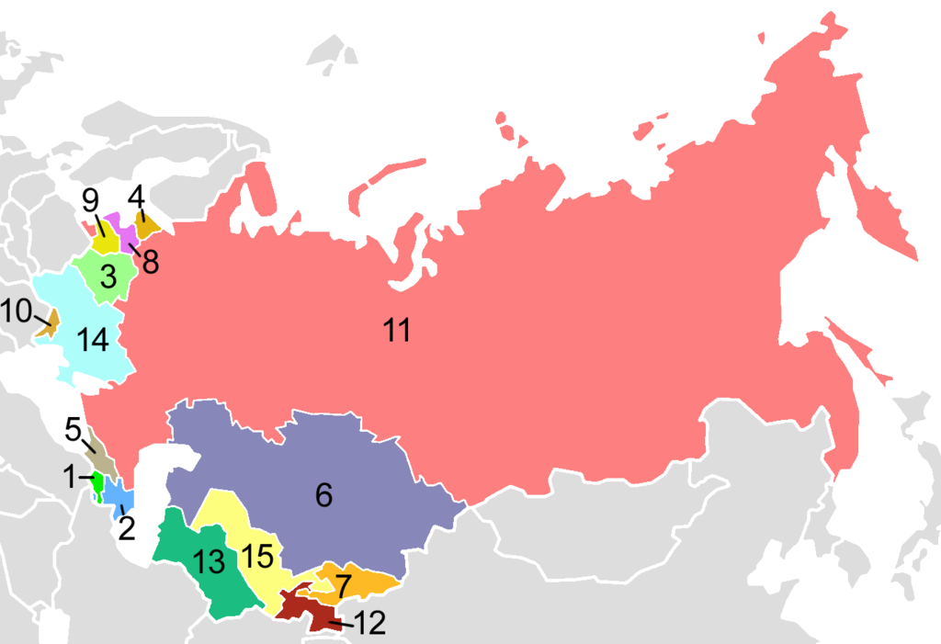
Post-Soviet states: 1. Armenia 2. Azerbaijan 3. Belarus 4. Estonia 5. Georgia 6. Kazakhstan 7. Kyrgyzstan 8. Latvia 9. Lithuania 10. Moldova11. Russia 12. Tajikistan 13. Turkmenistan 14. Ukraine 15. Uzbekistan
So when President George Bush the Elder, who was no wimpy Yale pacifist, promised Gorbachev in 1989 that in return for his acquiescence to the re-unification of Germany that NATO would not move " a single inch to the east", he wasn't exactly selling the "free world" (as they called it) down the drain.
In fact, as the above map unfolded, the 77-Years War that had incepted in August 1914 was finally over. If you want to count bodies, 150 million were killed by all the depredations which germinated in the Great War, its foolish aftermath at Versailles, and the march of history into the second world war and cold war which followed inexorably thereupon.
To wit, upwards of 8% of the human race was wiped-out during that span. The toll encompassed the madness of trench warfare during 1914-1918; the murderous regimes of Soviet and Nazi totalitarianism that rose from the ashes of the Great War and Versailles; and then the carnage of WWII and all the lesser (unnecessary) wars and invasions of the Cold War including Korea and Vietnam.
So finally the time had come for Washington to lead the world into a golden age of peace, disarmament and prosperous commerce among the nations.
Yet there was a virulent threat to peace still lurking on the Potomac after the 77 Years War ended. The great general and president, Dwight Eisenhower, had called it the “military-industrial complex” in his farewell address.
But that memorable phrase had been abbreviated by his speechwriters, who deleted the word “congressional” in a gesture of comity to the legislative branch.So restore Ike’s deleted reference to the legislative pork barrels and Sunday afternoon warriors of Capitol Hill and toss in the legions of beltway busybodies that constituted the civilian branches of the cold war armada (CIA, State, AID, NED etc.) and the circle would have been complete.
It constituted the most awesome machine of warfare and imperial hegemony since the Roman legions bestrode most of the civilized world.
In a word, the real threat to world peace circa 1991 was that Pax Americana would not go away quietly into the good night.
In fact, during the past 27 years Imperial Washington has lost all memory that peace was ever possible at the end of the cold war. Today it is as feckless, misguided and bloodthirsty as were Berlin, Paris, St. Petersburg, Vienna and London in August 1914.
Needless to say, there is no peace on earth today for reasons mainly rooted in Imperial Washington----not Moscow, Beijing, Pyongyang, Tehran, Damascus, Mosul or Raqqah. The former has become a global menace owing to what didn't happen in 1991.
What needed to happen back in 1991 was for Bush the Elder to declare "mission accomplished" and slash the Pentagon budget from $600 billion to $250 billion.
So doing he should have demobilized the military-industrial complex by putting a moratorium on all new weapons development, procurement and export sales; dissolved NATO and dismantled the far-flung network of US military bases; slashed the US standing armed forces from 1.5 million to a few hundred thousand; and organized and led a world disarmement and peace campaign, as did his Republican predecessors during the 1920s.
Unfortunately, George H.W. Bush was not a man of peace, vision or even mediocre intelligence. He was the malleable tool of the War Party, and it was he who single-handedly blew the peace when he plunged America into a petty arguement between the impetuous dictator of Iraq and the greedy Emir of Kuwait that was none of our business.
By contrast, even though liberal historians have reviled Warren G. Harding as some kind of dumbkopf politician, he well understood that the Great War had been for naught, and that to insure it never happened again the nations of the world needed to rid themselves of their huge navies and standing armies.
To that end, he achieved the largest global disarmament agreement ever made during the Washington Naval conference of 1921, which halted the construction of new battleships for more than a decade.
And while he was at it, President Harding also pardoned Eugene Debs. He thereby gave witness to the truth that the intrepid socialist candidate for president and vehement anti-war protestor, who Wilson had thrown in prison for exercising his first amendment right to speak against US entry into a pointless European war, had been right all along.
In short, Warren G. Harding knew the war was over, and the folly of Wilson's 1917 plunge into Europe's bloodbath should not be repeated at all hazards.
The Unforgiveable Sins Of George H.W. Bush
Not George H.W. Bush. The man should never be forgiven for enabling the likes of Dick Cheney, Paul Wolfowitz, Robert Gates and their neocon pack of jackals to come to power----even if he did denounce them in his bumbling old age.
Even more to the point, by opting not for peace but for war and oil in the Persian Gulf in 1991 he opened the gates to an unnecessary confrontation with Islam. In turn, that nurtured the rise of jihadist terrorism that would not haunt the world today-----save for forces unleashed by George H.W. Bush's petulant quarrel with Saddam Hussein.
We will address more fully on another occasion the 45-year old error that holds the Persian Gulf is an American Lake and that energy security requires it be patrolled by the Fifth Fleet. As history proves, the real answer to high oil prices everywhere and always is high oil prices and the wonders they work to rebalance the global energy market.
But first it is well to remember that there was no plausible threat anywhere on the planet to the safety and security of the citizens of Springfield MA, Lincoln NE or Spokane WA when the cold war ended.
But rather than dismantling the NATO machinery, virtually the opposite happened. NATO has been expanded to 29 countries including such powers as Slovenia, Slovakia, Bulgaria, Romania and now the statelet of Montenegro that has a military half the size of the police force of Philadelphia.
In the context of this relentless and pointless NATO expansion to the very borders of the shrunken Russian state, Washington not only sponsored and funded the overthrow of Ukraine’s constitutionally elected government in February 2014. But once it had unleashed a devastating civil war, it relentlessly blocked the obvious alternative to the bloodshed that has claimed 10,000 civilian and military casualties.
That is, it's partition of its population among
- the Russian speaking provinces in the Donbas and Crimea and
- Ukrainians in the west.
After all, partition was accomplished peacefully in the artificial state of Czechoslovakia and at the insistence of NATO bombers in the short-lived nation of Yugoslavia.

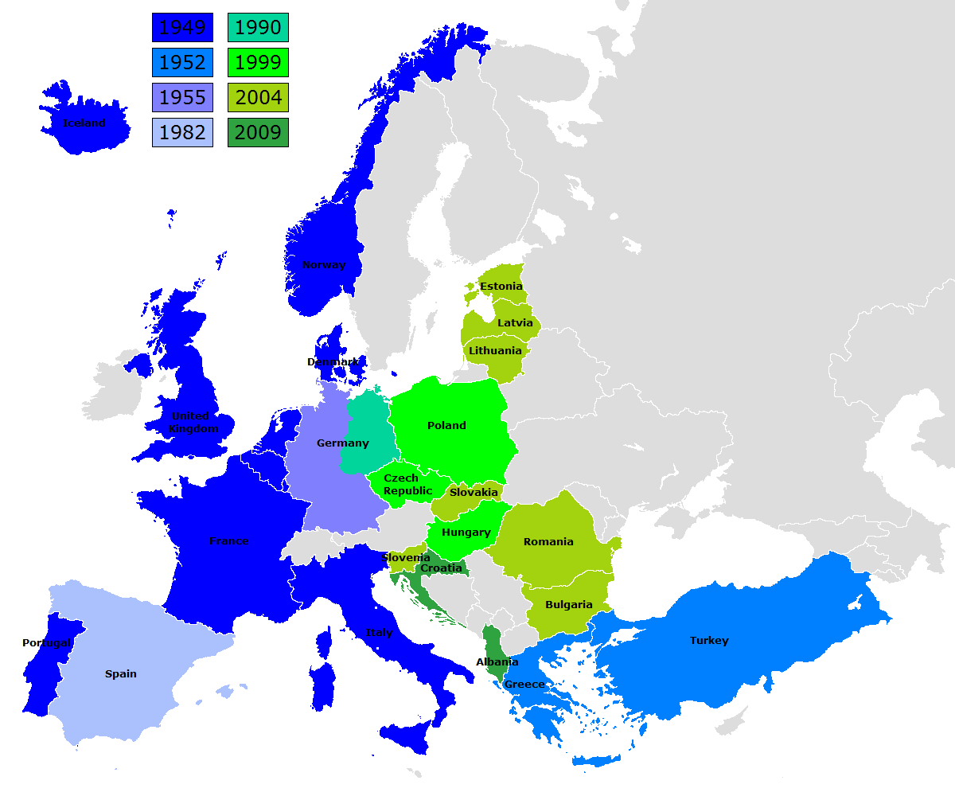

Had not the Donald been stopped cold by the hail of hysteria which emanated from the War Party and their dutiful stenographers in the main stream media, the next step after his historic meeting with Putin in Helsinki would have been to take up where George H.W. Bush faltered in 1991.
That is, on the dismantlement and interment of NATO and the re-opening of Europe to peaceful commerce among all the nation's that had been artificially separated by the now long departed Iron Curtain.
The fact is, Washington doesn't need its budget-busting $720 billion defense budget to defend Europe from Russia, nor should it be endlessly haranguing those nations to waste more of their own money on defense than they already are.
That's because there is absolutely no reason to believe that Russia wants to attack Germany or any other country in Europe. Indeed, the very idea is just plain madness.
As shown by the table below, the NATO-28 (excluding the US) are now actually spending $250 billion per year on defense (2017). That's 4X Russia's entire military budget of $61 billion.
Likewise, the GDP of Russia is but $1.5 trillion compared to $18 trillion for the NATO-28. So is Cool Hand Vlad so completely foolish and reckless as to think that he could invade and occupy territories that have an economy 13X bigger than that of Russia?
Actually, it's far more ludicrous than that. The rump of Russia today is a giant hydrocarbon province attached to some wheat fields, timber lands and mineral deposits---all dependent upon an aging work force afflicted with an undue fondness for Vodka etc.
What that means is that Russia must export its commodities big time or die. In fact, during 2017 Russian exports totaled $357 billion or 26% of its GDP. And 55% of that went to Europe!
Moreover, when you breakdown Russian exports it is plain to see that the industrial maw of Europe is the port of first call for its vast tonnages of exported commodities. These included $173 billion of oil and gas and $60 billion of iron, steel, aluminum, precious metals, forest products, fertilizers, grains and copper, among others.
Finally, the table on defense spending by country below speaks for itself as to the purported Russian threat. If the German government really feared that Russian tanks would be soon rolling through the Brandenburg Gates, it would have more than 20 operational tanks, and it would spend far more than $40.6 billion or 1.2% of GDP to defend itself.
And the same is even more true of the former Warsaw pact countries that are located cheek-by-jowl on Russia's border. Yet Romania spends the tiny sum of $2.8 billion or 1.2% of GDP on its military.
Likewise, the figure for Hungary, which learned all about Soviet-style invasions in 1956, spends only $1.2 billion or barely 1.0% of GDP. And besides that, its intrepid leader, Viktor Orban, doesn't even support NATO's ridiculous sanctions on Putin's cronies and allies.
And as for the allegedly threatened Baltic states, their combined defense budgets are less than $1.5 billion, representing a miniscule 1.7% of combined GDP; and Bulgaria, fast upon the Russian Lake called the Black Sea, spends only $660 million or 1.4% of its GDP.
In short, European policy action on the defense spending front trumps all the hot air that wafts from NATO's spanking new Brussels headquarters. Their governments and parliaments positively do not think they are threatened by the Russian Bear because they aren't.
What would help alot, therefore, is for the Great Disrupter to forget about his unfortunate infatuation with the idea that bigger is always better, and do what no other American politician in thrall to the Warfare State has been unable to do since 1991 when the Soviet Union vanished.
That is, declare "mission accomplished" with respect to NATO and disband it forthwith.
You could call it a Mercy Killing. Indeed, a couple more NATO summits at which they are browbeat to waste ever more money on defense, and the Europeans themselves may well start begging for exactly that.
Then again, could you imagine how loudly the progressive left would be screaming if the Donald even entertained the thought deep beneath his bedraggled Orange Comb-Over?
